**

**Alabama State Department of Education  
Educator Certification Section**

**Registering for a Criminal History Background Check with Fieldprint**

**Applicants will need:**

* A computer, tablet, or smartphone with internet access
* A valid email account
* Established AIM account
* ALSDE ID#
* Fee of $44.95 paid by debit card, credit card, or PayPal account (prepaid debit card or credit cards are acceptable)
* Ability to provide commonly known personal information (SSN, DOB, DL#, Height, Weight, etc.)

**Be sure your applicants follow the required sequence below. If they do not, they will not be able to complete the process successfully.**

Step 1: Create an AIM Account

Step 2: Complete Background Check Registration in AIM

Step 3: Create Fieldprint Account

Step 4: Complete authorization forms, schedule appointment, and fee payment

Step 5: Report for fingerprint appointment

1. Start by visiting our ALSDE Identity Management website at <https://aim.alsde.edu> and select “Need an account.” Follow the prompts to complete your AIM account.

**Note: Existing AIM users should simply log into AIM by entering their ALSDE ID# or Email address and Password.**

1. After your AIM account is created, log into AIM and select the ‘Fieldprint Background Check’ tile as shown below.

2.1 Press the ‘Set’ button under Educator certification and Criminal history Background checks

**Note:** It is the applicant’s responsibility to provide accurate information. Failing to do so, may result in a significant delay of the background check review. The user needs to keep up with their ALSDE ID# assigned in AIM. That number will be referenced when attempting to schedule an appointment with Fieldprint.

2.2 Enter Race and Ethnicity details and select ‘Save’ and then ‘Continue to Citizenship.’

2.3 Enter Citizenship details and select ‘Save’ and then ‘Continue to Phone Numbers.”

2.4 Enter Phone Number details and select ‘Continue to Home Address.’ **Note:** At least one phone number is required for registration.

2.5 Enter/Edit Home Address details and select ‘Continue to Characteristics.’

2.6 Enter Characteristics and select ‘Save’ and then ‘Continue to Birth Details’

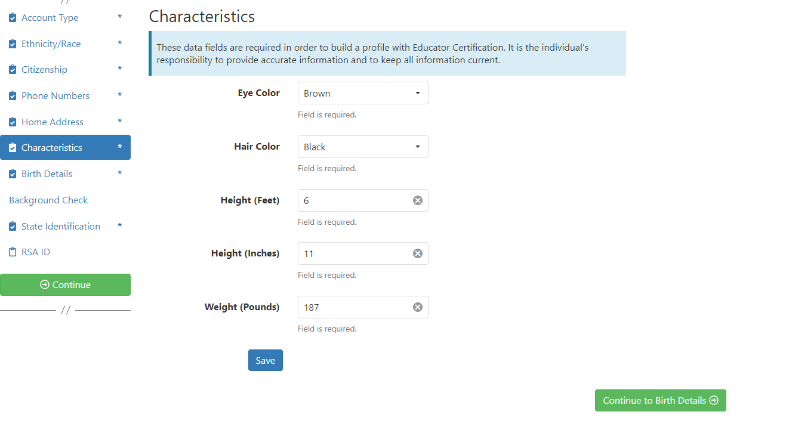

2.7 Enter Birth Details and select ‘Save’ and then ‘Continue to Background Details.’

2.8.a The applicant will select the reason they are seeking the background check.

2.8.b Revised!! Next, the applicant will select the type of institution they are seeking employment with, the name of the institution, and answer the question regarding convictions.

2.8.c Applicant answers questions regarding convictions and then selects ‘Save’ and

‘Continue to State Identification.’ **Note:** If the applicants select ‘Yes’ a pop-up message

will be displayed informing the applicant to send additional information to the ALSDE.

**Note:** A ‘Yes’ response **does not** prevent the applicant from completing registration.

2.8.d FBI Demographics: The FBI Demographics screen has been added to our

registration process. The addition of this screen gives us the opportunity to align data

collected on Race, Place of Birth, and Country of Citizenship with FBI requirements.

This will eliminate errors that applicants frequently found if they entered certain

information into these fields. The applicant should enter requested information based on

available options and select “Save” to record their selections.

2.9 Enter State Identification details and select ‘Save’ and ‘Continue to RSA ID.’

2.10 Revised!! Enter RSA ID details and select continue. Note: RSA ID number is optional. If you you’re your eight digit RSA ID# enter it in the fields as shown. If you do not have, or do not know your RSA ID number simply select ‘No’ and ‘Continue’ to complete your AIM registration.

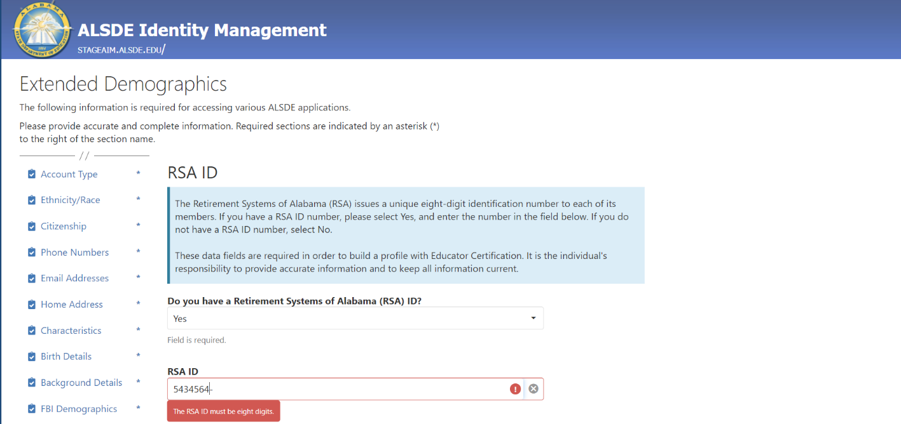

2.11 Applicant should record their ALSDE ID# for use later in the process.

3. Select ‘Sign Up’ to begin. Note: The applicant has been transitioned to Fieldprint.

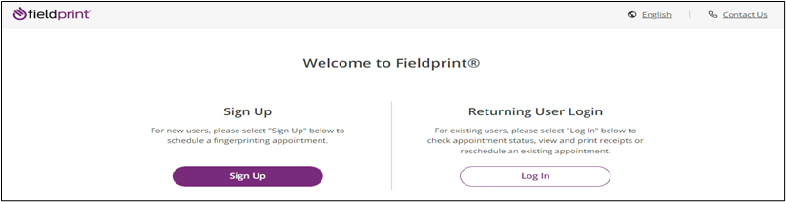

3.1 User will review Fieldprint Authorization form and select ‘I Agree.’

3.2 User enters information to create including Username, Password, and Security

Questions and selects ‘Continue.’ **Note:** Please record your password and security questions and answers securely. Answers to security questions cannot be duplicated.

3.3 Following the completion of screen 3.2 the user will be taken to the ‘Verify Account’

screen. **Note:** An 8-digit code will be sent to the email account entered on the previous screen. Enter the 8-digit code and select ‘Complete Registration.’

3.4 User is returned to the Login screen. Select ‘Log In’ to continue with registration.

3.5 Provide answer to security question and select ‘Continue.’ **Note:** This Question and Answer was created during account creation with Fieldprint.

**3.5.a NEW!! Reason Page:** The applicant should simply scroll to the bottom of the page to find AL-Department of Education and then select “Continue with this Reason.”

**Note**: If any other reason is selected the results will not be sent to the ALSDE and the applicant will need to repeat the registration process correctly.

* 1. Enter ALSDE ID#, Last Name, and DOB and select ‘Continue’

* 1. Enter contact information and select ‘Continue.’

* 1. Review AL DOE Release form and select ‘I agree’ then ‘Continue.’

* 1. Review Fieldprint Biometric Disclosure form and select ‘I agree’ then ‘Continue.’

3.10 Review the FBI Noncriminal Justice Applicant Privacy Rights Statement and select ‘I acknowledge…’ then ‘Continue.’

* 1. Review the Privacy Act Statement and select ‘I acknowledge…’ then ‘Continue.’

**Schedule Appointment and Payment**

4.1 Enter full address, city, state or zip code and select ‘Find’ to determine find the

Fieldprint locations nearest you and select an appointment date. Next select an

‘Find Availability’ to schedule an appointment time. **Note:** The business

name, address, and other information will be displayed.

4.2 Select ‘Part of day’ and time of requested appointment.

* 1. Select ‘Debit or Credit Card’ or ‘PayPal’ as your payment option.

**$7.95  
$37.00  
$44.95**

* 1. Insert Payment Account Information

**$7.95  
$37.00  
$44.95**

* 1. Review appointment details and log out. Note: Email confirmation of the appointment will be sent. The email will include a list of approved forms of identification that must be presented during your fingerprint appointment. Be sure to review procedures for canceling an appointment, if needed.

$37.00  
95

$44.95  
95

